27.60: a)
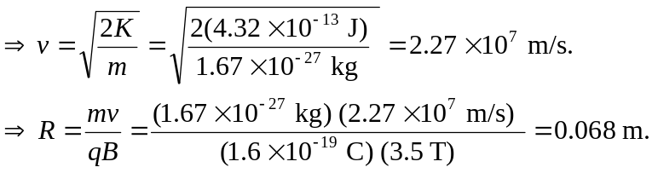
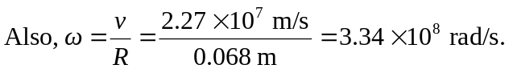
b) If the energy reaches the final value of 5.4 MeV, the velocity increases by , as does the radius, to 0.096 m. The angular frequency is unchanged from part (a) at 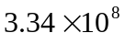rad / s.

